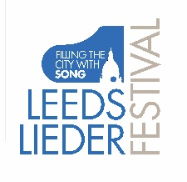
LEEDS LIEDER YOUNG ARTISTS PROGRAMME 2021

FESTIVAL MASTERCLASSES

Sunday 20 June, 3 – 6pm
Victoria Hall Risers

Festival Masterclass IV and presentation of the Leeds Lieder/Schubert Institute UK
Song Prize
with James Gilchrist and Anna Tilbrook

Esme Bronwen-Smith mezzo-soprano
Avishka Edirisinghe piano

Poulenc Bleuet

Schubert Der Musensohn

Howells King David

Ava Dodd soprano
Joanna Kacperek piano

Walton from Façade
Old Sir Faulk

Schubert Lied der Mignon

Amy Beach Ah Love, but a day!

Lorna McLean soprano
Claire Habbershaw piano

Poulenc C

Barber from Hermit Songs
The Crucifixion

Grieg Ein Traum

Dafydd Jones tenor
Shile Liu piano

Britten from Seven Sonnets of Michelangelo
Veggio co’ bei

Chaussson Le Colibri

Schubert from Die schöne Müllerin
Der Neugierige

Magnus Walker tenor
Eunji Han piano

Schubert Willkommen und Abschied

Poulenc from Deux poèmes de Guillaume Apollinaire
Dans le jardin

Britten from Winter Words
Midnight on the Great Western (The journeying boy)

