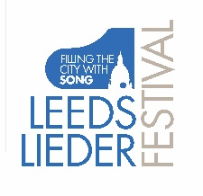

LEEDS LIEDER YOUNG ARTISTS PROGRAMME 2021

FESTIVAL MASTERCLASSES

Thursday 17 June 3 – 6pm
Victoria Hall Risers

Festival Masterclass I
with Iain Burnside

Marie Cayeux soprano
Feilin Liu piano

Debussy from Ariettes oubliées
Il pleure dans mon coeur

Rachmaninov Dreams (Op, 38 no. 5)

Jake Heggie Animal Passion

Victor Kassebeer baritone
Stella Marie Lorenz piano

Schubert from Winterreise
Erstarrung
Frühlingsraum

Britten from Tit for tat (De la Mare)
Vigil

Lorna McLean soprano
Claire Habbershaw piano

Poulenc C

Barber from Hermit Songs
The Crucifixion

Copland Heart, we will forget him

Ellen Mawhinney soprano
Mark Rogers piano

Debussy from Fêtes galantes
Fantoches

Duparc Au pays où se fait la guerre

Walton from Façade
Old Sir Faulk

Cassandra Wright soprano
Ilan Kurtser piano

Duparc L’invitation au voyage

Rachmaninov What happiness Op. 34 No. 12

Britten from On this Island
Seascape

