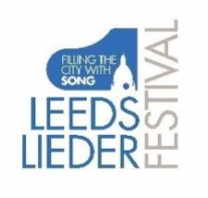
LEEDS LIEDER YOUNG ARTISTS PROGRAMME 2022
FESTIVAL MASTERCLASSES

Saturday 30 April, 10am-12.30pm Linacre Studio – Howard Opera Centre
Festival Masterclass III with Graham Johnson OBE

10am Charles Cunliffe baritone
Michel Xie piano

Schubert from Schwanengesang
Der Atlas, D.957, No.8
Gurney In Flanders
Brahms from 4 Lieder
An die Nachtigall, Op.46, No.4

10.25am Karla Grant soprano
Jia Ning Ng piano

Poulenc from Métamorphoses, FP.121
II. C’est Ainsi que tu es
III. Paganini
C. Schumann Liebst du um Schönheit

10.50am Angharad Rowlands mezzo
Joseph Cavalli-Price piano

Schubert Der Zwerg, D.771
Gurney Thou didst delight my eyes
Brahms from 49 Deutsche Volkslieder
Da unten im Tale, WoO33, No. 6

11.15am Felix Emmanuel Gygli baritone
JongSun Woo piano

Schubert Auf der Bruck, D.853
Duparc Phydilé
Schumann from Fünf Lieder
Der Soldat, Op.40 No.3

11.40am Katrine Deleuran Strunk soprano
Aleksandra Myslek piano
Schubert Erlkönig, D. 328
Berg from 7 Frühe Lieder
No. 2 Schielflied
A. Mahler Einsamer gang

12.05 Kirsty McLean soprano
Sharon Cheng piano

Debussy from Ariettes oubliées
Green
Spleen

